**DSO 545 City of LA - Homeless Project （Group16）**

**Key Findings**

**Team Member: Xudong ZHANG, Zhuoqun SHENG, Jue SONG**

# **Background**

To track homelessness operations in Los Angeles in an effective and timely manner, we developed a Shiny R interactive app to find the potential impacts of different homelessness intervention strategies. We dig into the homeless issue from three aspects: **crime, shelter provider** and **311call service**. The datasets used in this project were provided by the Mayor’s office staff. Analysis and suggestions were discussed below.

# **Crime Data**

## **2.1 Recode the variables**

After finding the Top 10 observations in variable crime category, premise and weapon, we recode them into different types:

* Crime Category - "AGGRAVATED ASSAULT", "SIMPLE ASSAULT", "ROBBERY","THEFT","RAPE","OTHERS"
* Crime Premise - "STREET", "SIDEWALK", "PARKING LOT","PARK/PLAYGROUND","DWELLING","OTHERS"
* Weapon - "STRONG-ARM", "KNIFE", "STICK","GUN","PIPE","OTHERS"

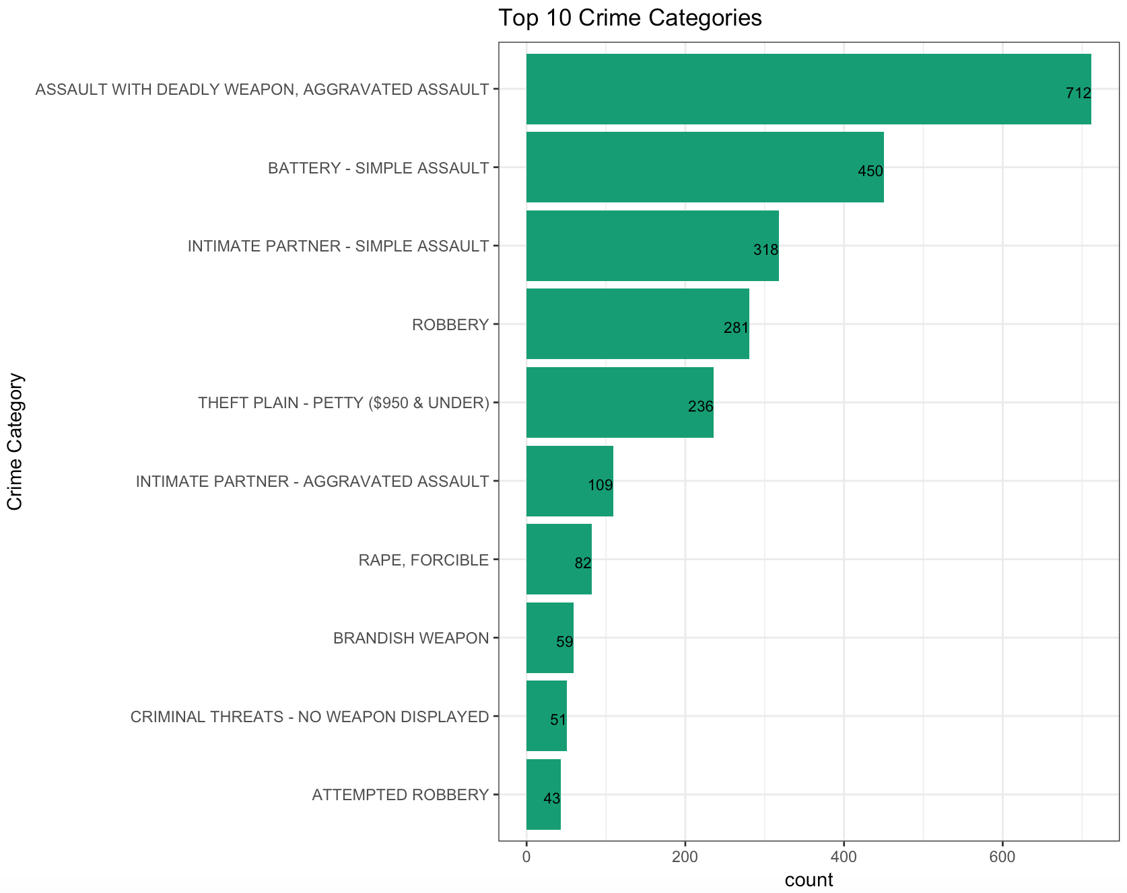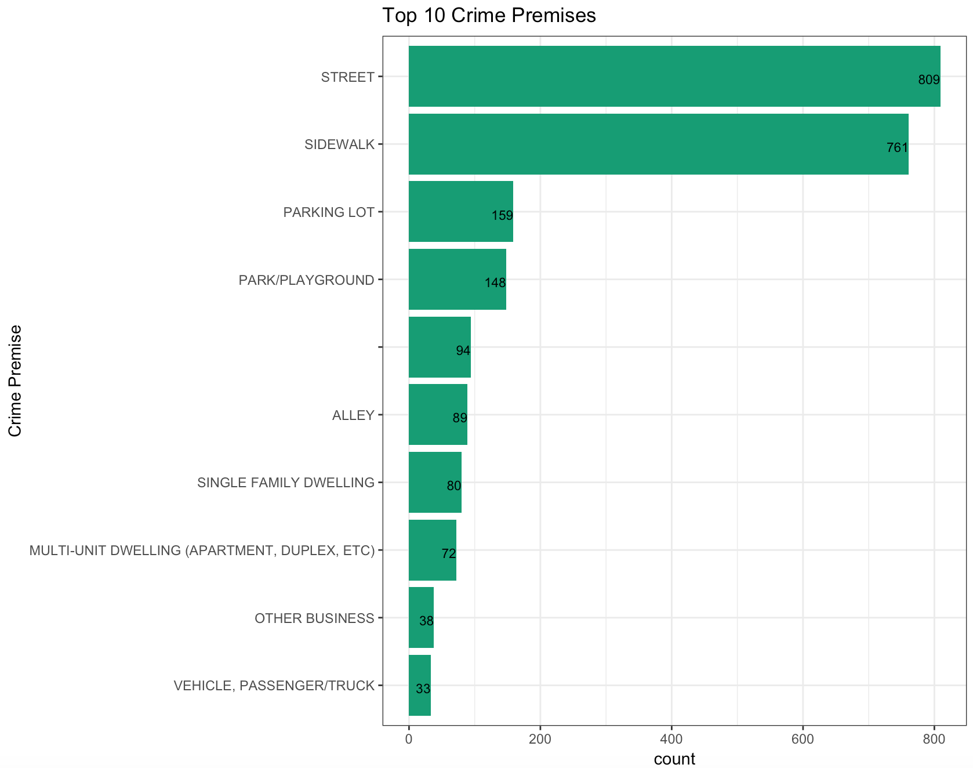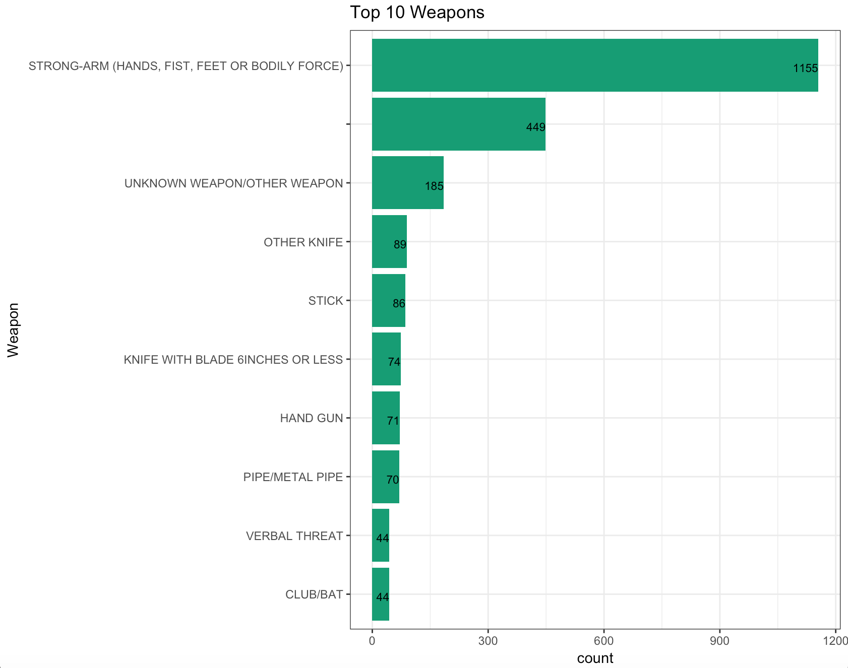

## **2.2 Peak Time**

We look into the time of the crime occurred based on a monthly basis and hourly basis. We found that August has the highest number of crimes, and most of the crime occurred at noon and at night, the peak hours are 12pm and 8pm-1am.

In addition, we found that the distribution of crime types didn’t change a lot among different months and different hours.

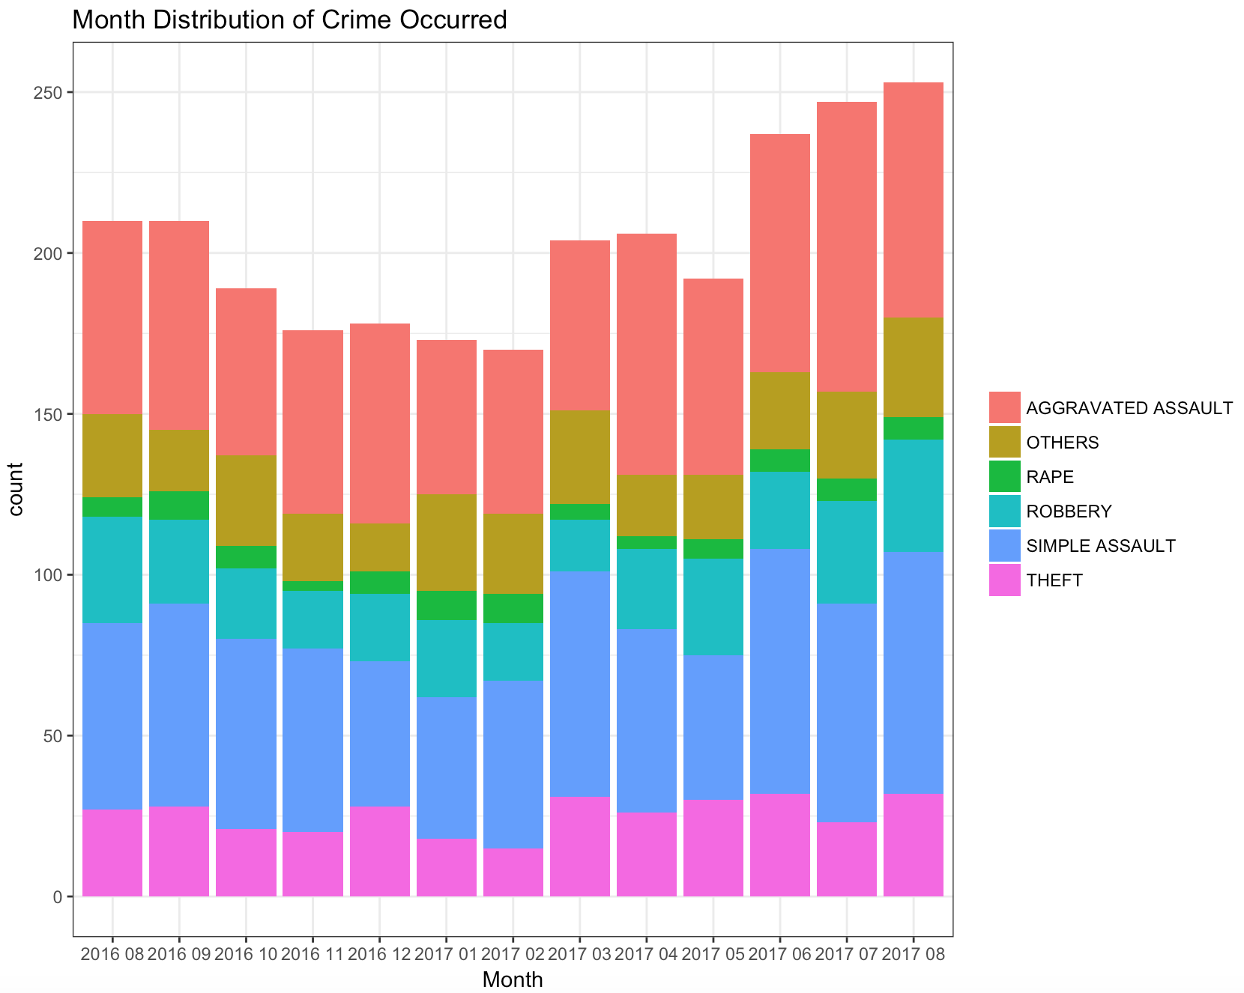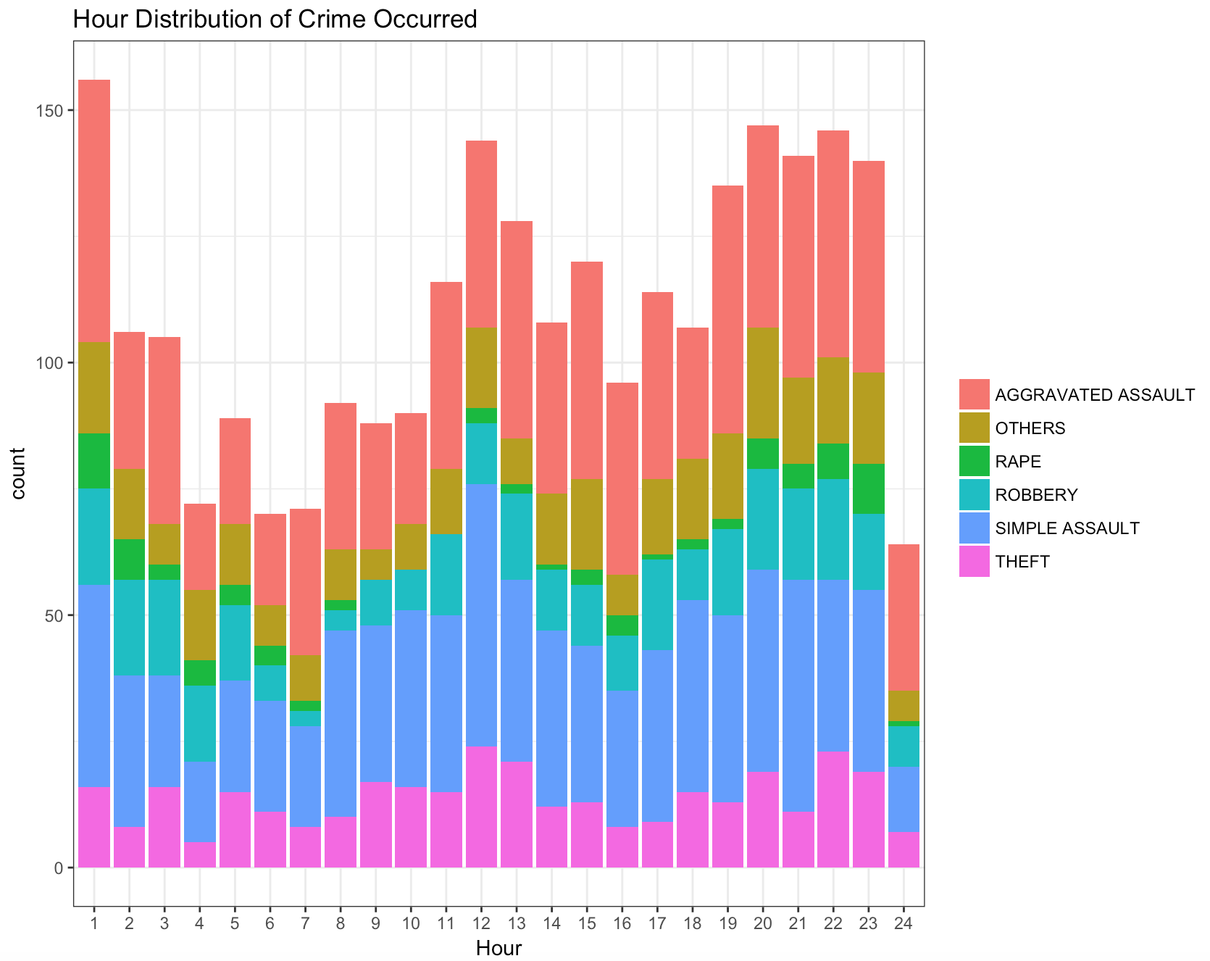

**2.3 Crime Type, Crime Premise and Weapon**

We are also interested in finding the relationship among Crime Type, Crime Premise and Weapon. There is no particular pattern found in Crime Type and Crime Premise, and different crime types seem to follow a common pattern. The majority of the crime occurred on the street and sidewalk. But it worth noticing that a certain proportion of the assault happened in the dwelling. In terms of the Crime Type and Weapon, strong-arm occupies the majority in simple assault and rape. Due to the missing info, some weapons are unknown.

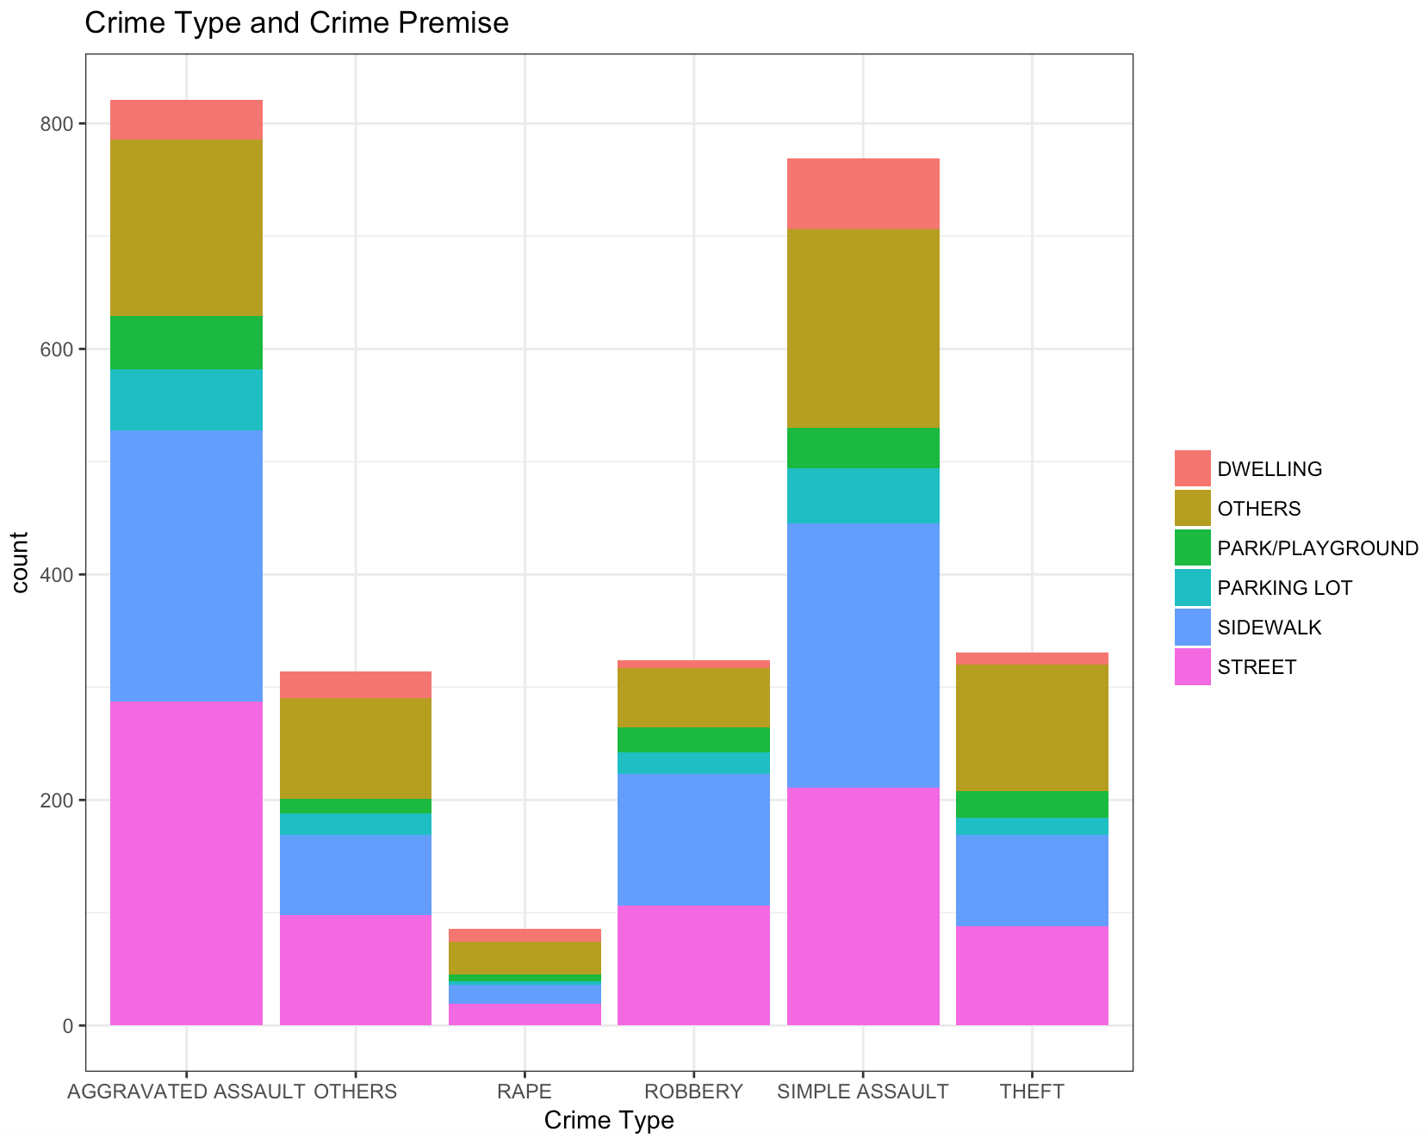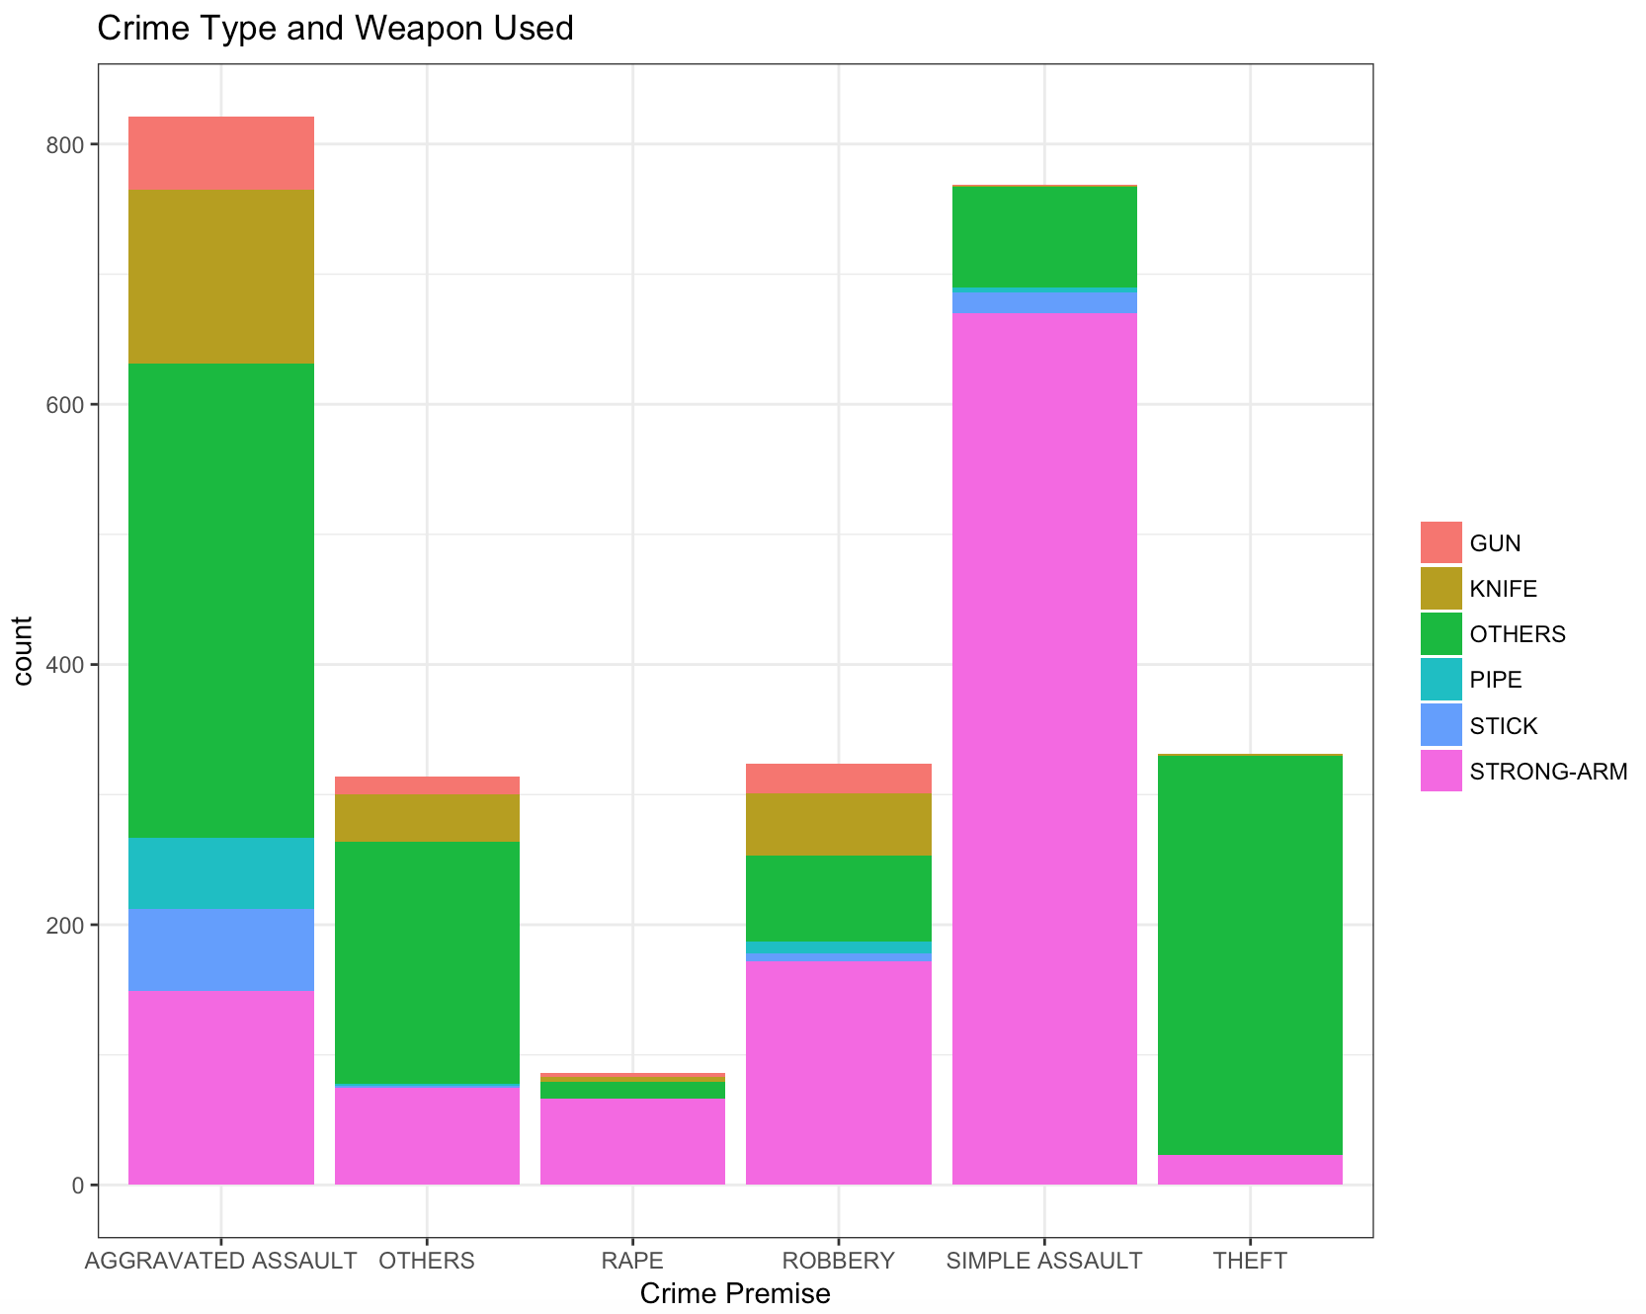

# **Shelter**

**3.1 Different Services Provided**

We found that there are 181 shelter providers in LA, and this number is quite satisfying. However, different shelters always provide different services, and we can learn the particular services from their description. For example:

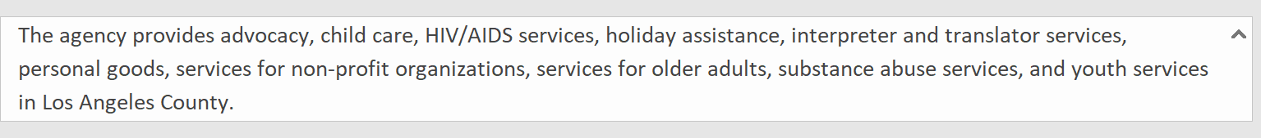

We can learn from this description that this shelter provides services such as advocacy, child care and so one. We also see that there is some limitation such as “for older adults”. We used text analysis to identity the services each shelter provides.

**3.2 Interactive Method**

To detect the running conditions of each shelter, a In the Shiny R App was built. The side bar provides multiple checkboxes for users to filter the data, and the App would automatically generate a table which contains basic information for the shelters fitting the conditions selected.

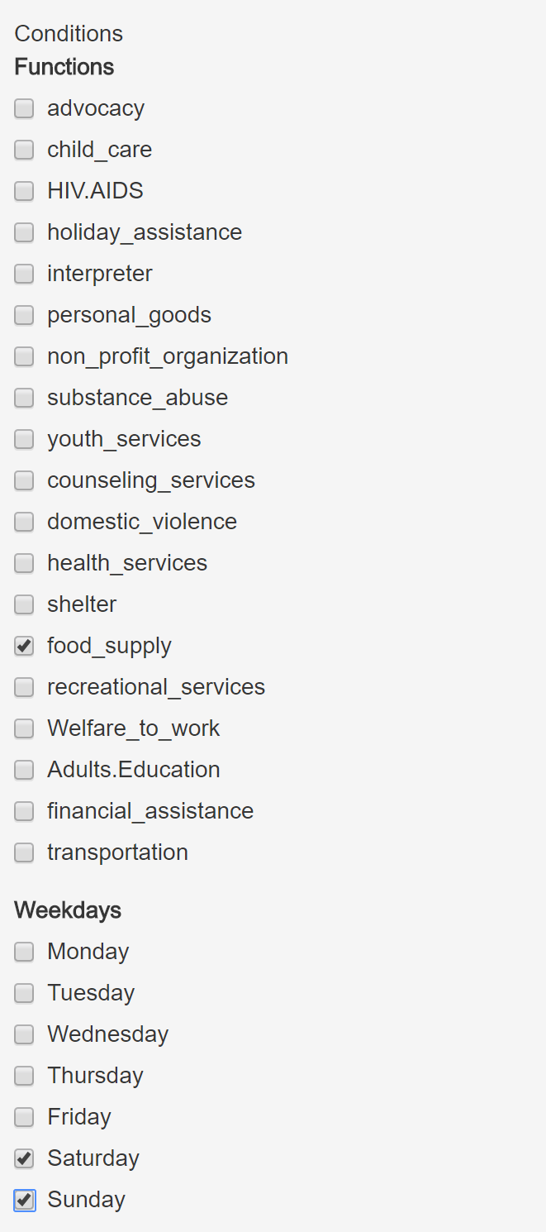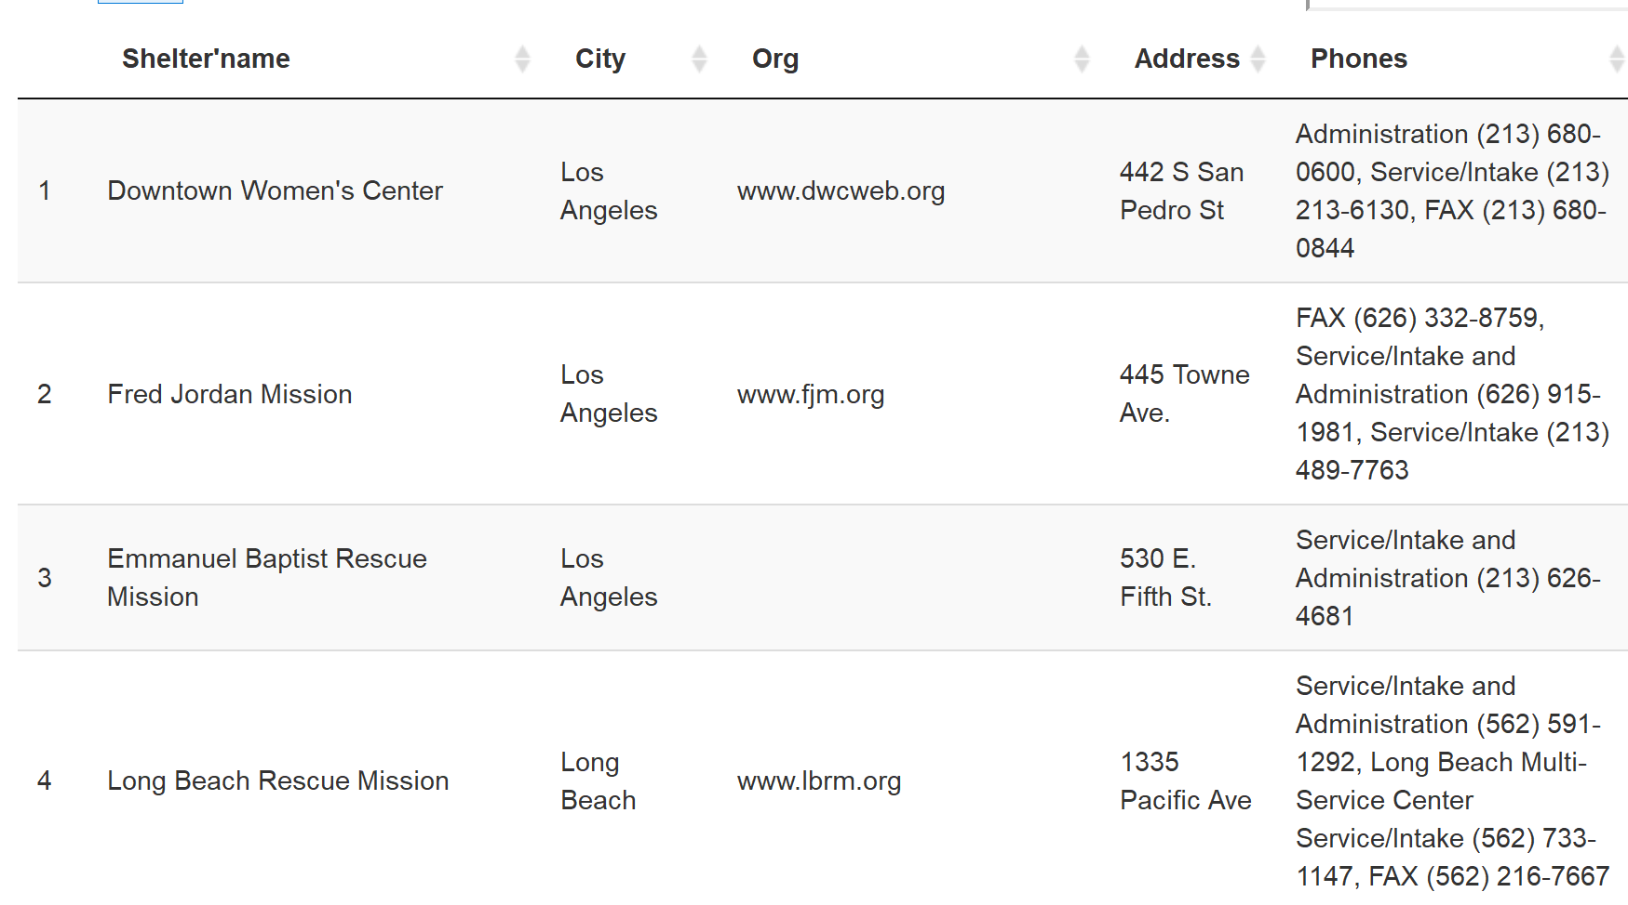

In the meantime, a map would be generated to mark the qualified shelters’ locations on the LA map. The colors here indicate which counties the shelters located in.

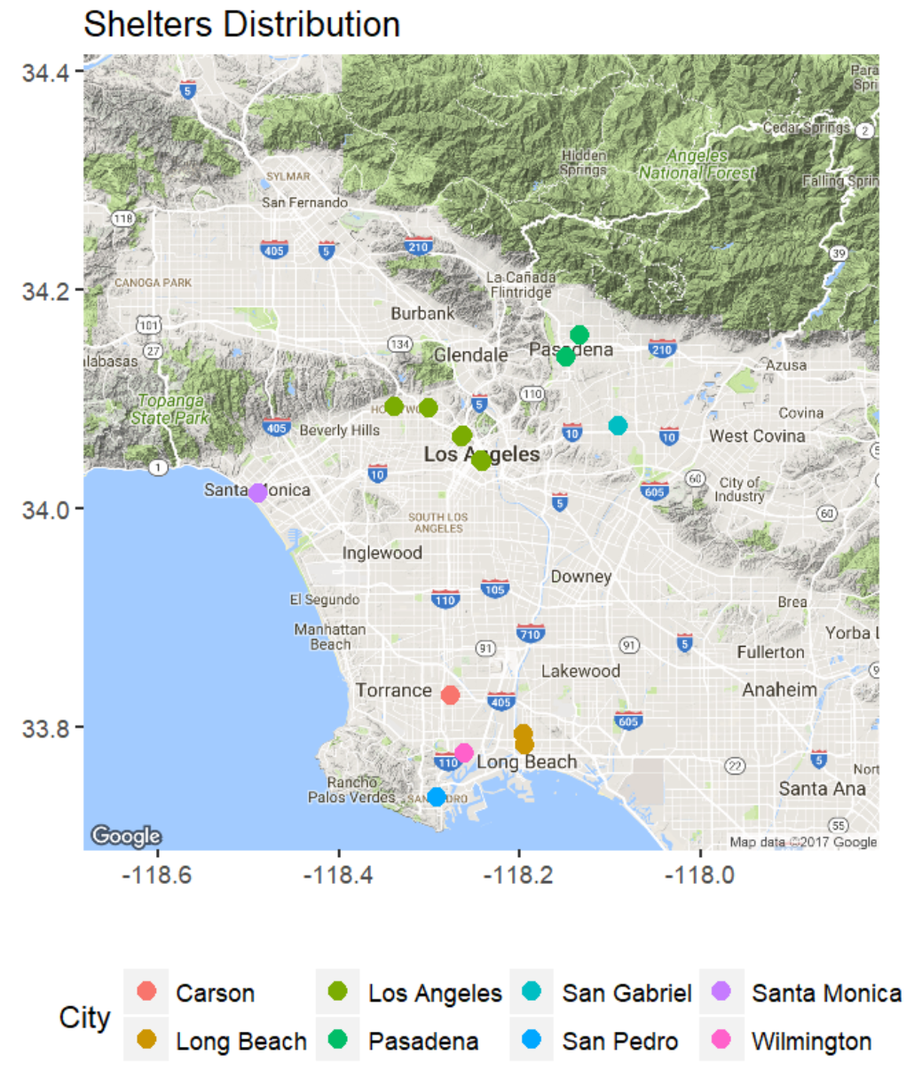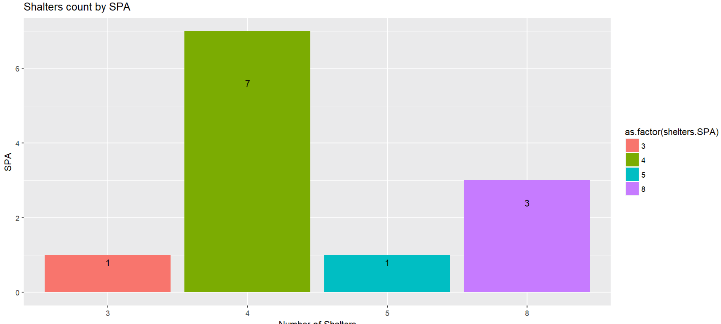

Another bar chart gives the count of qualified shelters in different SPA. We can find that Most of shelters with shelter services are concentrated in SPA 4. Most of shelters away from downtown will closed during weekend. Several services are not distributed evenly among LA; they are: child care, personal goods, substance abuse, youth services and financial services. Some are well distributed such as holiday assistance.

# **311 call Data**

The very useful information about 311 calls is the service date and service status, using this we can explore more about the service positivity and capability of 311, regarding homeless encampment.

**4.1 311call Service Positivity**

We plan to measure the problem-solving positivity by official response time. The key assumption we made here is that, the problem-solving positivity could be represented by the time difference btw service date and request created date. We set a standard of different response time levels, by which we fill the bars into different colors.

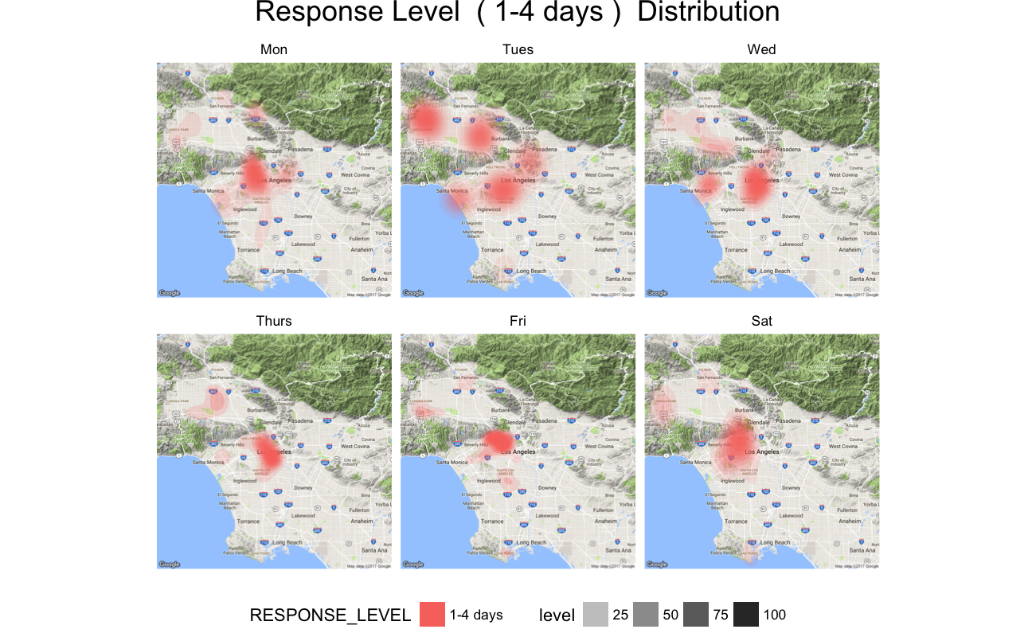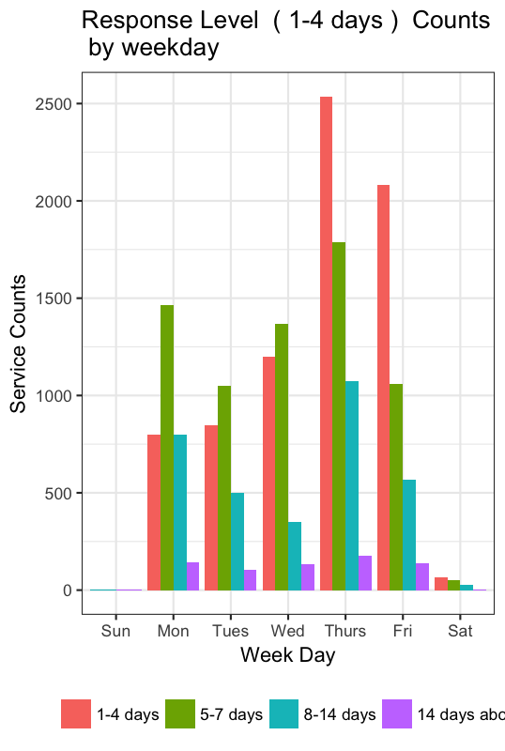

Then, we will explore the response time level on a geospatial dimension and facet the plot by which weekday the service date is. To see if there is any time and location preference of 311 to response to homeless encampment.

And, and we do find that on Monday and Friday, the plot is much less denser, maybe that’s because of the beginning or the end the weekdays? And they are mostly concentrated in central LA. Another surprising thing is that On Sunday, 311 does tremendous work to respond to the homeless issue, not only in terms of number, but also area range.

**4.2 311call Service Capability**

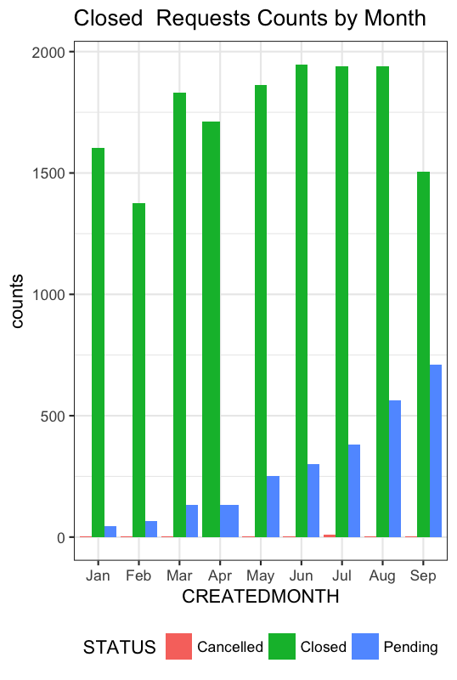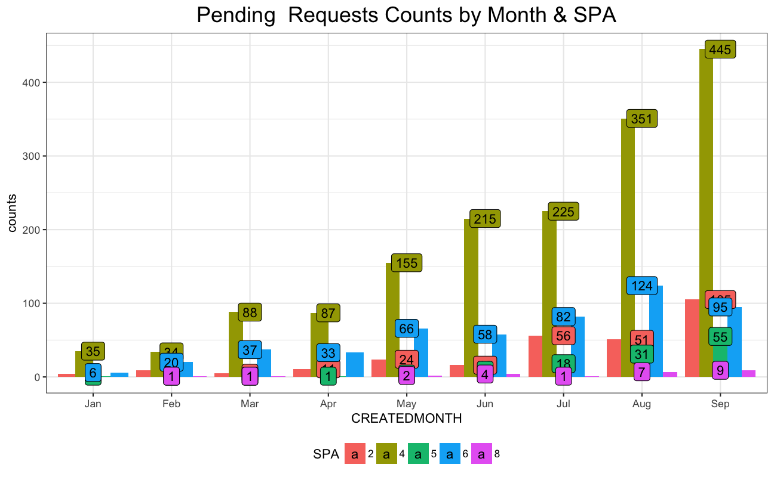

From the upper left plot, we can see a slightly growing trend of closed request counts on a monthly basis, indicating the slow growth of 311call’s homeless encampment solving ability. However, we can see a clearing rise in the counts of pending requests. And we can find this rise comes from SPA4 after we break down all the pending requests.

To pick the subset of “Closed requests”， as we can see from the bars charts above, the number of closed requests fluctuates month over months in all the five SPAs SPA 2 and SPA 4 outperform in the closed request category and demonstrate a growing trend in the first eight month. But both SPAs fail to achieve more in September.

# **Suggestions**

1. Crime types didn’t change a lot among different months and different hours, indicating the good maintenance of social security.
2. Several services are not distributed evenly among LA (including child care, personal goods, substance abuse, youth services and financial services). More allocation concern should be put on to this in the future.
3. 311 call pending request are growing in SPA4. The government should study what the cause is and try to fix this.
4. Responses to 311 call from SPA2 are seemingly negatively prioritized in 2017. If this happens conventionally, homeless immigration cross LA SPAs may be stimulated.